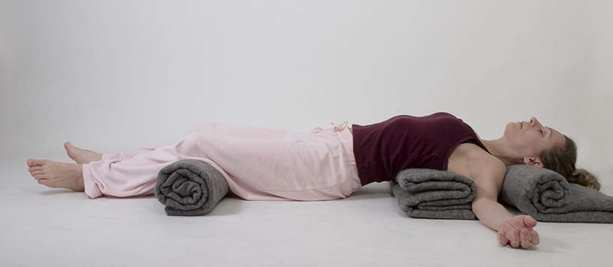
“Some things in life cannot be fixed, they can only be carried.”
-Megan Devine-

Restorative Yoga for Grief and Loss
Navigating Our Journey of Grief
Restorative Yoga is a practice of deliberate stillness, a practice focused on restoring well-being and helping you find a new way to live with loss. Restorative Yoga helps you to relax deeply, understand how and why grief permeates you so intensely, and provides tools to help navigate your way to honoring your loss while finding a way to live in this strange new world.
Four two hour sessions include breath work, poses, guided meditation and mindfulness.
When: Classes are held on Tuesdays. Summer Session Dates: July 11, 18, 25, Aug. 1
9:00-11:00 Restorative Yoga for Grief for those grieving the death or terminal illness of a loved one
12:00-2:00 Restorative Yoga for Life Transitions for those grieving the loss of health, a relationship, job, pet or other life transition.
Where: The beautiful, private and tranquil setting of The Wellness Spa Resort in Stevens Point
Preregistration is required, no drop-ins. Class size limited to 6. No yoga experience necessary. Poses are able to be adapted for almost anyone regardless of age or physical fitness, but being able to get down on the floor allows for the fullest participation.
Complete 4 session program $120. To register: Call/Text Judy at 715-347-0621 or E-mail: judyraye77@gmail.com. See our Facebook page @EarthWondersYoga for current schedules.
“This is a great opportunity for those going through grief. You are providing not only an outlet in the class itself, but you provide so much each session that we can take away and utilize every day.”
- Laura G, Hospice Nurse and
Class Participant

